M. Kishore CB.EN.U4CYS21032

Q1.

#include <pthread.h>

#include <stdlib.h>

#include <stdio.h>

#include <unistd.h>

// printWelcomeMessage will be called when the Thread is created in the main function

// which takes string as an argument

struct myname{

int val1;

int val2;

}a;

void *printWelcomeMessage(void *threadid) {

sleep(2);

long tid=(long)threadid;

printf("\n[THREAD] Hello, Welcome %ld.", tid);

pthread_exit(NULL);

}

int main () {

// thread defintion

pthread_t threads[5];

// parameter to be passed to the called function - printWelcomeMessage

char threadid[10][15] = {"Amritha","Praveen","Saurabh","Sangeetha","Lakshmy","Srinivasan","Ramaguru"};

int result;

for(int i = 0; i < 7; i++ ) {

printf("\n[MAIN] Creating thread, %d", i);

// Creating the threading and thus calling the function with parameter passed to it

result = pthread_create(&threads[i], NULL, printWelcomeMessage, (void *)threadid[i]);

if (result) {

printf("Error in creating thread, %d ", result);

exit(-1);

}

}

// Exit the thread

pthread_exit(NULL);

}

OUTPUT:

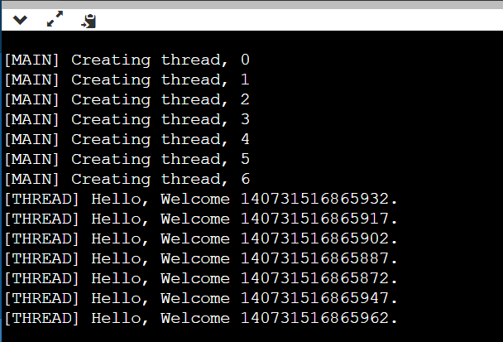

Q2.

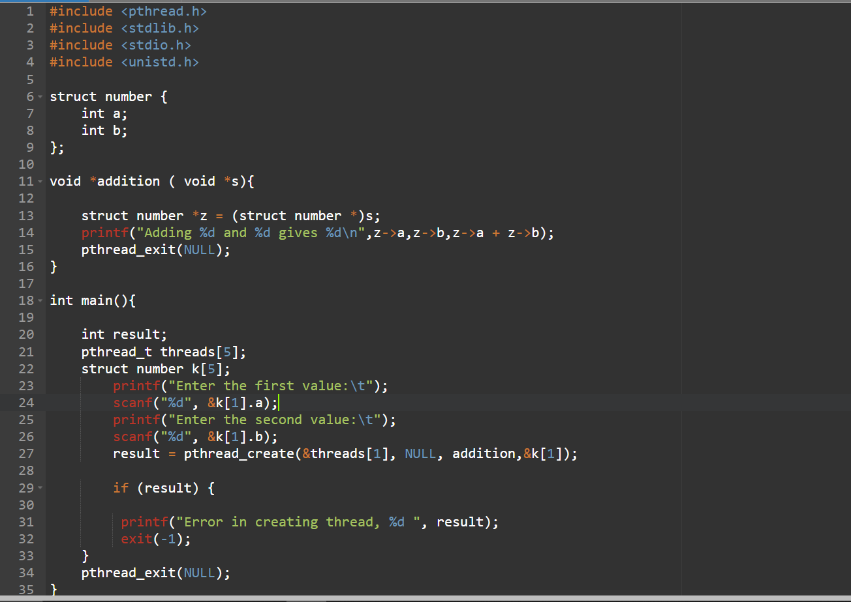

Output:

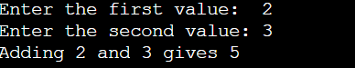

Q3 using null

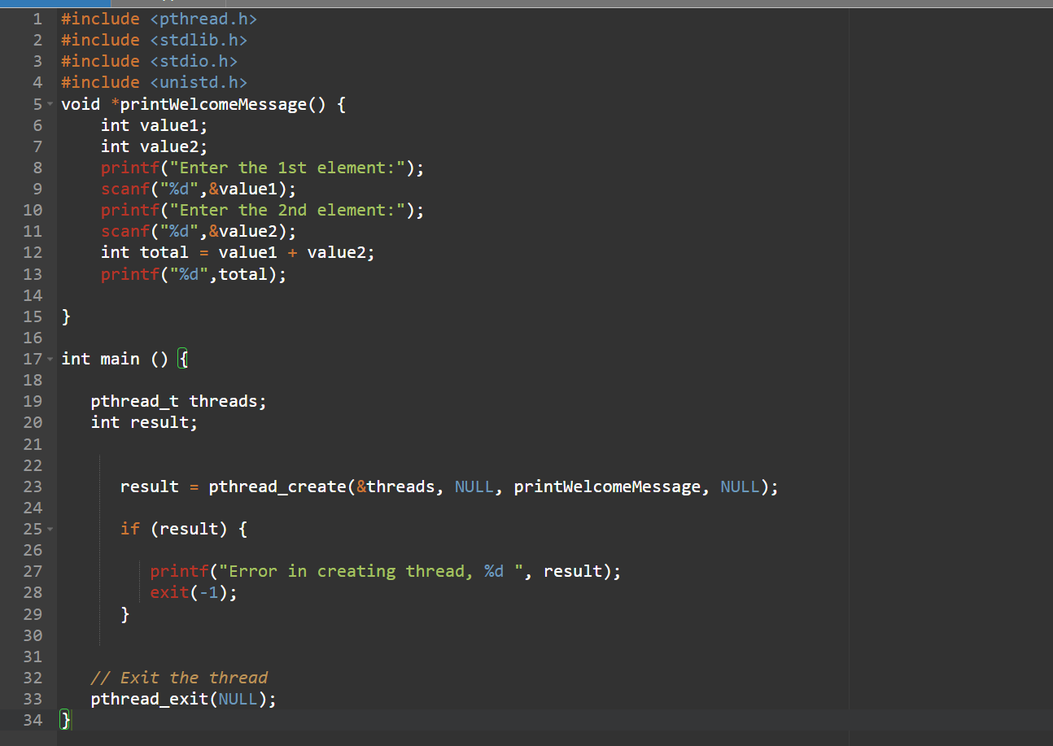

Output

